Test | Type | Description | Test Steps | Test Data | Expected Results | Actual Results | Status (Pass/Fail)
1 | Functional | Issue Business Cheque Book: Verify that a valid Business Account can request a cheque book and that the system records it. | 1. Find Customer (John Helix).  2. View Accounts.  3. Select Business Account.  4. Select "Issue Cheque Book". | Account: Business (Sole Trader)  Action: Option 4 (Issue Cheque Book) | System displays "Success: Cheque book issued." The database updates the account flag to prevent duplicates. | Worked as intended. Display the message “Success: Cheque book issued” | Pass
2 | Functional | Duplicate Cheque Book Prevention: Verify that the system prevents issuing a second cheque book to the same account. | 1. Use the same account from Test 1.  2. Select "Issue Cheque Book" again immediately. | Account: Business (Sole Trader) Action: Option 4 (Issue Cheque Book) | System displays error: "Error: A cheque book has already been issued". No changes made to the database. | Display the correct error message. And no changes to the customer's database data. | Pass
3 | Functional | Set up & Execute Standing Order (Immediate): Verify that a Standing Order set for today (or a past date) is paid immediately during processing. | 1. Select Personal Account.  2. Set up Standing Order.  3. Enter Date = 26/01/2026  4. Return to Main Menu.  5. Run "End-of-Day Processing". | Recipient: Landlord  Amount: £10.00  Date: Yesterday's Date  Action: Option 4 (Processing) | System setups standing order and displays: "Success: Standing Order set for Landlord starting 26/01/2026”  Sender account balance decreases by £10. | System worked as intended, displaying the right message and deducting the right amount. | Pass
4 | Functional | Future Direct Debit (No Payment): Verify a Direct Debit set for a future date is NOT paid when processing runs. | 1. Select Personal Account.  2. Set up Direct Debit.  3. Enter Date = Next Month.  4. Run "End-of-Day Processing". | Recipient: Gym  Amount: £50.00  Date: [Next Month's Date] | Setup: "Success: Direct Debit set..."Processing: System runs but skips this payment (not listed in "PAID"). Balance remains unchanged.
5 | Robustness | Scheduled Payment Insufficient Funds. Verify that the system handles a scheduled payment gracefully when the account has insufficient funds. | 1. Create a new Personal Account (£1 balance).  2. Set up a Standing Order for £1000 (Today).  3. Run "End-of-Day Processing". | Balance: £1.00  Amount: £1000.00 Date: 26/01/2026 | Processing: Output shows "> FAILED: £1000.00 to ... - Insufficient Funds". Account balance does not go negative (beyond the limit).
6 | Input Validation | Negative Payment Setup: Verify that a user cannot set up a Standing Order for a negative amount (stealing money). | 1. Select Personal Account.  2. Set up Standing Order.  3. Enter a negative amount. | Recipient: Thief Amount: -£100.00 | System displays "Error: Invalid amount" or "Amount must be positive". The database is NOT updated.

Test 1
Step 1. Finding Customer (John Helix).
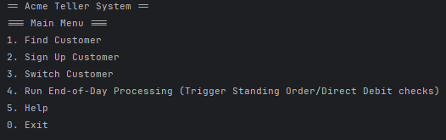

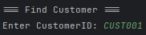
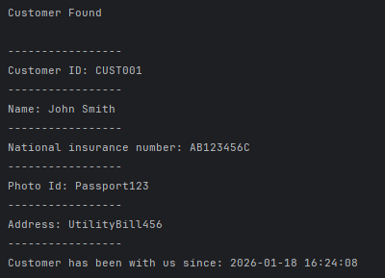

Step 2. View the account(s) associated with this customer.
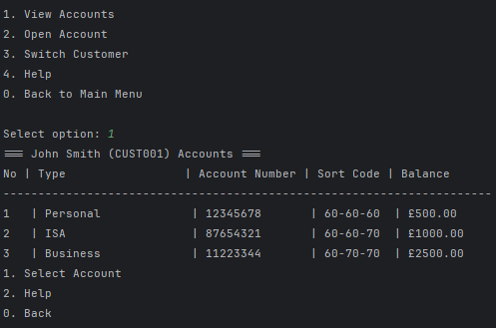

Step 3. Select the Business Account.
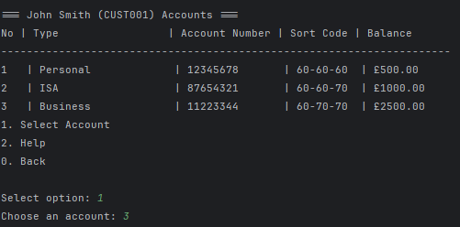

Step 4. Select "Issue Cheque Book".
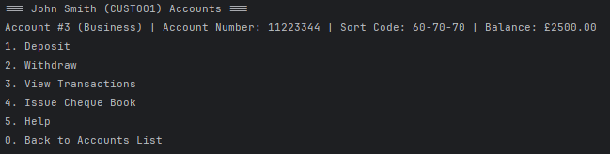

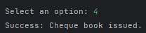
Database
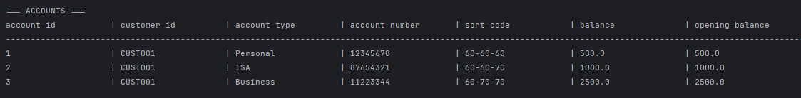
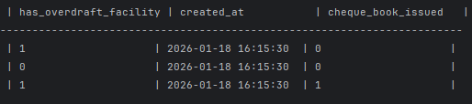

Test 2
Step 1. Use the same account from Test 1.

Step 2. Select "Issue Cheque Book" again immediately.
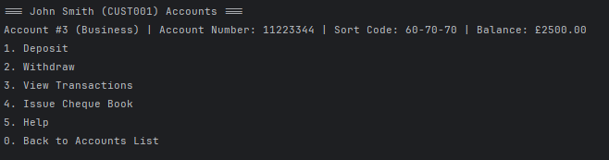
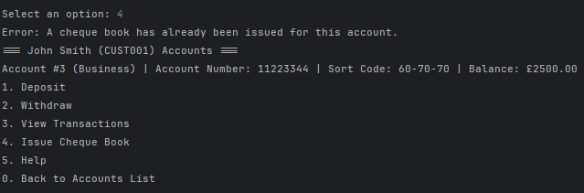

Database

Test 3
Step 1. Select Personal Account.

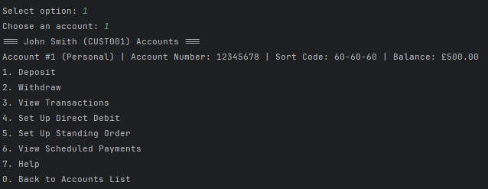
Step 2. Set up a Standing Order.
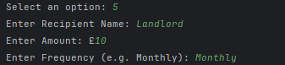

Step 3. Enter Date: 26/01/2026
Step 4. Return to the Main Menu and run "End-of-Day Processing".

